**SIKKIM**

Sikkim is located in the north-eastern part of India. Sikkim has shared borders with West Bengal in the south, Tibet in the north and northeast, Bhutan in the east, Nepal in the west, and Sikkim in the west. It is close to the Siliguri Corridor in India. Sikkim is the second-least populous and poorest of the Indian nations. Sikkim, which is a region of the Eastern Himalaya, is well known for its biodiversity, which includes both alpine and tropical climates. It also serves as the home to Kangchenjunga, the third-highest mountain on Earth and the highest peak in India. Sikkim's capital, Gangtok, is the state's biggest metropolis. Khangchendzonga National Park is located in the state and covers around 35% of it. The Namgyal dynasty created the Kingdom of Sikkim in the 17th century. It was ruled by the Chogyal, a Buddhist clerk-king. It reached a kingly state of British India in 1890. Sikkim maintained its mandate status with the Republic of India after 1947. Sikkim had the highest per capita income and knowledge rate of any Himalayan state. Anti-royalist cries were heard in front of the palace of the Chogyal in 1973. The Sikkimese people overthrew the monarchy in 1975. Following a vote in 1975, Sikkim became the 22nd state to join India. India's ultramodern Sikkim is a bilingual and multiethnic state. Lepcha, Sikkimese, Nepali, and English are the official languages of the nation. The state of Nepal has sanctioned the use of the languages Gurung, Limbu, Magar, Mukhiya, Newari, Rai, Sherpa, and Tamang among others for the preservation of culture and heritage. Government documents and seminaries both use English. The two main ideologies are Vajrayana Buddhism and Hinduism. In spite of having the third-lowest GDP among Indian states as of 2014, Sikkim is one of the fastest-growing states because to its reliance on agriculture and tourism.

**History of Sikkim**

The history of Sikkim comprises intriguing stories of ups and campo, of strong and weak leaders, and of battles between numerous races.

Sikkim, the name of the state began from the words su him – which means new house. The early occupants of this region known as Lepcha, assimilated with the other lines similar to Mon, Chang, and Naong. The Bhutia's began to enter this area during the 14th century. In the time 1642, the Kingdom of Sikkim was created, wherein Phuntsog Namgyal, the first chogyal( spiritual and temporal king), was from the Bhutia community. The Namgyal dynasty ruled Sikkim for a long time till the time 1975.

During the mid-18th century, there were numerous territorial wars between Sikkim and both with Nepal and Bhutan. Nepal was victorious to enthrall many corridors of western and southern Sikkim. It was during this time when a huge number of Nepalese migrated to Sikkim. During the time 1816, Sikkim supported the British in the Anglo- Nepalese War By this time, the power of the Chogyals was reduced as British rule came into place. In the time 1890, Sikkim came a protectorate state under British rule. According to this Sikkim will be a buffer between British India and China, and would be under the governance and control of the British. The East India Company captured Darjeeling, which was originally a part of Sikkim. This move by them was clearly not respectable to the Sikkimese people. The Namgyal dynasty did try to bandy this issue with the British people. After a long struggle, the British conceded Sikkim as the kingly state under the rule of the Namgyal dynasty. But the control of the state was still with the East India Company.

When India got independence in the time 1947, numerous political parties were formed in Sikkim. During this time, Sikkim was still under the rule of the Namgyal dynasty. In the time 1950, the Indo- Sikkimese convention was inked, wherein it came to a protectorate state of India under the rule of this dynasty. Palden Thondup Namgyal was the last monarch of the state when it started to lose control over the people of Sikkim. The new political parties formed began to surpass the church and the Buddhist monarchy. The kingliness of the Namgyal dynasty began to fade, and ultimately, the Indian administration took over the state. Sikkim came to the sanctioned state of India in the time 1975, under the rule of Indira Gandhi.

Sikkim state has a relatively vast history and this can be observed in numerous literal places in Sikkim similar to the Coronation Throne of Norbugang, Rabdentse, and others.

**Culture of Sikkim**

The state of Sikkim is a classic illustration of the admixture of different traditions, persuasions, and customs of different communities. Since ancient times, the state has been enthralled by three major lines, videlicet, the Bhutias, the Lepchas, and the Nepalese. Indeed though people from other countries would have migrated then the state has still retained its oneness.

The culture and tradition of Sikkim are like various bouquets adorned with traditions, folk balls, and customs of colorful lines. The myriad societies of Sikkim can be reflected in their places of deification, artistic balls, and carnivals. As per the Sikkimese culture, Nature is considered as God. This is proven by the lush verdure, gutters, timbers, and mountains of the state.

The main language of Sikkim is Nepali, followed by Bhutia, or Sikkimese, and Lepcha. Other languages that are also spoken in this state are Limbu, Majhwar, Tamang, Sherpa, and Tibetan.

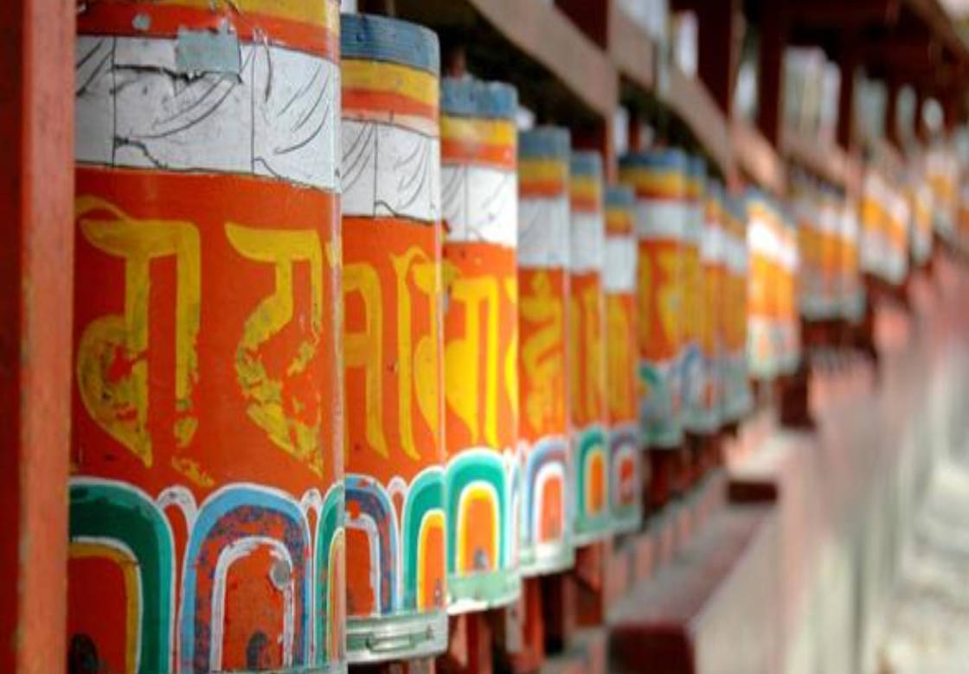

*Fig1: culture of Sikkim*

The food of Sikkim reflects the culture of the state that's a mix of Tibet, India, Bhutan, Tibet, and Nepal. Sikkim food generally comprises Sinki and Gundruk mists, polls, fermented soybean, traditional cabin rubbish, thukpas, fermented rice products, and bamboo shoots. The staple food of Sikkim is Rice. Excursionists visiting Sikkim would like to try flirts and momos.

**Traditional Dress of Sikkim for Men and Women:**

The dress of Sikkim reflects the social life and culture of the major lines. All 3 major lines have different types of costumes. The traditional dress of a Lepcha woman is known as Dumvum. Dumvum is ankle- length dress that's worn like a saree. Another traditional dress of women is known as Tago. It's a loose-fitted dress worn along with a blouse, hat, and belt. The traditional vesture of Lepcha men is Thokro- dum which includes a shirt, a pajama, Yenthatse, and hat. Generally, the dress of Sikkim people is conducive to the fieldwork. The traditional dress of women and men of the Bhutia lineage is known as Kho or Bakhu. Bakhu is tied at the midriff with a silk or cotton belt.

**The Ancient medical system in Sikkim**

The Ancient medicinal systems are still in use in Sikkim, where Buddhist organisations frequently use the ancient Tibetan pharmacopoeia in combination with Ayurvedic medicines. Lepcha, Bhutia, and Nepalis are Sikkim's three largest ethnic groups, and they form the foundation of traditional medical practises and the artistic values that go along with it. In this study, a semi-structured questionnaire including topics like age and coitus, educational background, knowledge source, practise types, experience and generation of practise, and knowledge metamorphosis was created for folk healers. These were given to 48 folk healers who were connected in a distinct Sikkim corridor.

The Lepcha, Bhutia, and Nepalis—three Sikkim's ethnic groups—have long practised their traditional drug regimens and strongly believe in sauces. Sikkim's wide ranges in height and temperature let its 490 drug stores find their niche. In Sikkim, ancient medicinal practises continue to be practised and are supported by Buddhist organisations for their traditional Tibetan pharmacopoeia. The Sikkim tribal people have a strong belief in herbal medicines that is based on generations of trial and error knowledge. The goal of all the colourful traditional healers around the world is to cure afflictions and preserve mortal health, however their practises and beliefs vary. Any medical system in society operates in accordance with the local creative manifestations and the terrain that prevails there. Geographical considerations in the Sikkim Himalaya haven't just facilitated this; they've also prevented direct contact with other highly developed indigenous drug systems. Because resources are scarce and the environment is severe, high

altitude mortal communities remain isolated. Their geographical setting encourages the growth of a distinctive health culture. This is a blend of Lepcha, Bhutia, and Nepali methods used in Sikkim to prevent complaints, promote health, and address complaints. These unusual customs are unrecorded and are passed down orally from one generation to the next. Studies on the demographics and usage trends of a common drug in different emerging nations are available. Although India has a rich knowledge base, strong beliefs, and acceptance, similar types of serious job are rarely offered there. Due to the uncertain future of their heritage, the current study set out to examine the vibrant stores Sikkim's folk healers employ, their practise patterns, demography, and socioeconomic status.

**Present status of medicine in Sikkim**

There are about 420 species of medicinal and sweet shops in Sikkim Himalaya. detail particulars of the important medicinal shops especially set up in Sikkim and used in Ayurvedic practice are given below. Abies forrestii C.C Rogers

1. Abies webiana Linn.F
2. Aconitum ferox wall
3. Aconitum hetrophyllum
4. Acorus calamus
5. Aloe barbadensis Mill
6. Angelica archangelica Linn
7. Artimisea vulgaris L
8. Asparagus recemosus Willd
9. Bergenia Lingulata (Har.)
10. Callicarpa macrophylla Vahl
11. Celastrus Paniculatus Willd
12. Cinnamomum tamal Nees & Eberm
13. .Costus speciosus
14. Dendrobrium nobile Lindl
15. Eupatorium cannabinum L
16. Hedychium spicatum Ham Ex. Smith
17. Mallotus philippinensis Muell
18. Nardostachya jatamansi DC
19. Oroxylum indicum Vent
20. Paederia foetida
21. Picrorhza kurroa Royle ex. Benth
22. Podophyllum hexandrum Royal
23. Rubia cordifolia Linn
24. Swertia chirata Buch.-Ham
25. Saussuria lapa C.B.Cl
26. Smilax lanceaefolia roxb
27. Texus baccata Linn
28. Valeriana hardwickii Wall
29. Zanthoxylum alatum Roxb

Up to 14 sizable pharmaceutical companies are currently based in Sikkim, and they have all made considerable investments there. These include the titans of the Indian pharmaceutical business, Cipla, Sun Pharma, Zydus Cadila, Alembic, IPCA, Alkem Lab, Intas Pharma, Torrent Pharma, and, of course, Unichem. In fact, organisations like Lupin are assessing the situation, according to assiduity conduit.

You won't believe it, but Sikkim, the state with the second-lowest population after Goa in the country, has previously attracted a pharma investment outlay of Rs. 500 crores. After Gujarat, Goa, and Baddi, Sikkim is now the focus of a lot of attention. This might garner major defences given that the country is the fourth-largest volume user of medications in the world.

" Sikkim is a peaceful country with a lot of manufacturing potential. The state government only occasionally interferes. It is true that the state needed some time to grow and draw the pharmaceutical corporations. Ramesh Kumar, who is in charge of the Cipla plant in Sikkim, claims that it has reached a turning point presently. The Cipla facility, which spans 12 acres, has been operational since April 2008.

Sikkim is enticing because of all the benefits provided by the government. When Sikkim was incorporated into the Centre's North East Industrial and Investment Promotion Policy, 2007, which was released in April 2007, it was successful. As a result, starting from the day the marketable product was introduced, all new units and units in Sikkim that apply for significant expansion will be eligible for incentives for a period of ten times.

**Healthcare In Sikkim**

The beautiful state of Sikkim is equipped with numerous health installations and medical services for the people. These medical installations are well equipped with ultramodern health technology outfits and tools to give advanced medical exigency treatment. Schemes are offered by the government in order. to give people a better mode of living and healthy life. The Sikkim government has also without fail handed a good number of schemes for its people to profit from. Janani Sishu Surakshya Karyakaram Scheme( JSSK) has been enforced in Sikkim since the time 2011 in order to exclude charges of pregnant women before as well as after delivery. The scheme exposure has been completed with active association from departments of Women and Child Development, NGO, ASHA, and AWW.

There are numerous hospitals, health centres, conventions, and health installations across the state of Sikkim. These medical installations give treatment both to the original cases and other cases from neighbouring places as well.

|  |  |  |  |  |  |  |
| --- | --- | --- | --- | --- | --- | --- |
| S.NO. | HEALTH INSTITUTION | EAST | WEST | NORTH | SOUTH | STATE |
| 1. | STATE REFERRAL HOSPITAL | 1 | - | - | - | 1 |
| 2. | DISTRICT HOSPITAL | 1 | 1 | 1 | 1 | 4 |
| 3. | COMMUNITY HEALTH CENTER | 1 | - | - | 1 | 2 |
| 4. | PRIMARY HEALTH CENTER | 6 | 7 | 5 | 6 | 24 |
| 5. | PRIMARY HEALTH SUB CENTER | 48 | 41 | 18 | 39 | 146 |
| 6. | DISTRICT TUBERCULOSIS CENTRE , NAMCHI | - | - | - | 1 | 1 |
| 7. | CENTRE REFERRAL HOSPITAL MANIPAL TADONG(PVT.) | 1 | - | - | - | 1 |
| 8. | TOTAL | 58 | 49 | 24 | 48 | 179 |

*Fig 2: Hospitals in Sikkim (Sikkim.gov.in)*

**Health and family department of Sikkim**

There have been many advancements made to the architectures, capacity structure, workforce placement, and provision of comprehensive services through 148 Primary Health sub-centers, 24 Primary Health Centres, 2 Community Health Centres, 4 District Hospitals, and 1 State Referral Hospital that operate under a public-private partnership model. The following health indicators, all of which have a substantial impact on the health of the Sikkimese population, have undergone significant change as a result of the amazing achievements the Sikkim government has made in the health sector:

**Demographic Indicators**  
1.Birth rate per 1000 people dropped from 24.6 in 1994, or 43.85%, to 16.5 in 2019. (SRS).

2. Total Fertility Rate dropped to 1.1 in 2019–20 from 129% (2.75) in 1998–99. (NFHS-V).  
  
**Death Rate Indicators**  
1. Crude Death Rate dropped from 35.29 % (6.9) in 1994 to 4.2 in 2019 per 1000 people (SRS).  
2. The infant mortality rate (IMR) fell from 142% (46) in 1994 to 5 in 2019.  
3. The rate of infant mortality fell from 121.87% (71) in 1998-1999 to 11.2 in 2019-20. (NFHS-V).

4. According to statistics from the Medically Certified Causes of Deaths 2006-2016 and the 1989-1990 (Survey), Noncommunicable Diseases have supplanted Communicable Diseases as the leading cause of death.

**Service Indicators**

1. Total vaccination coverage grew by 100.63%, or from 48% in 1998-1999 to 96.3% in 2020-21. (as per state report).

2. From 70% in 1994 to 85% in 2020, there was a 21.42 percent increase in the tuberculosis cure rate (State Report).

3. Between 2005–2006 and 2020–21, institutional delivery increased by 100.82%, or from 49% to 98.4% (State report).

4. Three or more prenatal visits are now often received by women, increasing from 45% in 1998-1999 to 74.7% in 2020-21, a 66% increase (State report).

5. Civil birth registration rates rose from 22.4% in 1994 to 85% in 2020, a 279.46% rise (State report).  
6. Civil Registration information was improved from 22% in 1994 to 85.5% in 2020, an increase of 288.63% (State report).

**Disease Prevalence**

1. Goitre prevalence decreased by 376.87% (54.03) from 1991 to 2005, then by 14.17% to 11.33% in 2016–17. (State Survey report).

2. In Sikkim, a Cretin Free State has been founded. The frequency in the 1989–1991 study was 3.36%.

3. Frequency Leprosy incidence per 1000 people decreased by 450%, from 1.10 in 1995 to 0.2 in 2014–15.

**Neurology in Sikkim**

A subspecialty of medicine called neurology looks into, diagnoses, and treats problems related to the breakdown and operation of the neurological system. The brain, spinal cord, and sensitive receptors including the eyes, brain, and skin are all parts of the nervous system.

A neurology specialist treats neurological conditions and neurological problems in a case which are basically diseases that impact the functioning of the nervous system there are several branches of neurology grounded on specializations when you consult neurologists online in Sikkim that are located in and around, like child neurology, neurosurgery, and neuromuscular drug.

One should see a neurology specialist in Sikkim that is located in and around if he/she witnesses symptoms like unforeseen changes in behavior, chronic back pain, or tremors and seizures. However, Alzheimer's, or any other neurological conditions, If one family has a history of neurological conditions like Parkinson's complaint, Alzheimer's, or any other neurological conditions, one hunt for a neurological clinic in Sikkim that is located in and around to consult with the stylish neurology croakers in Sikkim that are located in and around also a quick hunt for neuro near me in Sikkim that is located in and around will also connect you to a good neurologist for a quick opinion.

Some common neurological conditions are aft pain, migraines, brain injury, brain tumor, cerebral paralysis, as Eimers, Parkinson's, madness, epilepsy, multiple silicosis, and stroke if you're passing any symptoms of the mentioned neurological complaint or if your family has a history of above you should consult a neurologist specialist in Sikkim that I located by and around or consult neurologist online at the foremost. Any illness or complaint related to the nervous system requires attention from a neurology specialist, who'll help you with an opinion and treat your neurological condition. Getting help is now easy in Sikkim that is located in and around.

Following is the list of stylish neurology centers in and around Sikkim:

1.) Central Referral Hospital

2.) STNM Hospital Sikkim

3.) Sikkim Pathology Clinic

4.) Metro Diagnostic Gangtok, Sikkim

5.) Health center singhik

6.) Dr. Malay's Hospital & Neuroscience Centre

7.) KINS Institute Of NeuroSciences

8.) Rudraksh Parkinsons Clinic

9.) Sanjeevani Neuro & Multi Speciality Hospital

1. **CENTRAL REFERRAL HOSPITAL:** On August 22, 1991, Shri R. Venkataraman, the concurrent President of India, laid the cornerstone for Central Referral Hospital. On March 4, 1997, Dr. Pawan Chamling, the Honourable Chief Minister of Sikkim, officially opened the facility. This has started a protracted journey to establish new standards for healthcare in this region of the country's north-east. A number of highly skilled medical professionals, cutting-edge equipment, a trained paramedical crew, and other support services are all conveniently located under one roof. It is a nine-story building with 500 beds and a bottom area of more than square feet. The Sikkim population now has access to modern, top-notch healthcare facilities just outside their front doors thanks to CRH.
2. **STNM Hospital Sikkim:** With the introduction of a 1,002-bed sanitarium in Gangtok, Sikkim now has the second-largest government hospital in India. The New Sir Thutob Namgyal Memorial Multi-Speciality Hospital was formally launched on Monday by Pawan Chamling, the chief minister of Sikkim, who described it as the second-largest medical facility in the country after the All India Institute of Medical Sciences (AIIMS) in New Delhi.
3. **Sikkim Pathology Clinic:** Among the finest in the megacity, Sikkim Pathology in Below Paradise Lodge, Gangtok is known for offering excellent case care. The clinic is located centrally in Below Paradise Lodge, a prominent position in the megacity. There are many of public transportation options available to get to the clinic from all the major locations of the megacity.
4. **Metro Diagnostic Gangtok:** Metro Diagnostic Gangtok, Sikkim, Gangtok has consistently been regarded as one of the top-ranking individual centres. Indeed, in a highly competitive environment, they have been able to preserve competitive advantages over all of their rivals simply because they have consistently provided exceptional service quality. Really, this is the end of the road for anyone looking for anything—from their qualified team of employees to their astute eye for preserving client pleasure. This is regarded as one of the main causes for their sizable clientele.
5. **Dr. Malay's Hospital & Neuroscience Centre:** Dr Malay's Sanitarium and Neurosciences Centre is a super thing tertiary care medical centre devoted to neurosciences. It has been set up with the end of furnishing comprehensive, accurate, and affordable neurological and neurosurgical services to the people of Siliguri, North Bengal and touching areas. Neurosurgery being one of the most prominent departments of the sanitarium, there has been a huge surgical workload since its commencement. The sanitarium is veritably well equipped with an array of individual and imaging modalities, ferocious Care units, nippy stroke, and trauma care installations, a good neurosurgical O.T., and overall a devoted platoon of medical and paramedical staff. The center also thrives for quality work and an instructive approach to the realm of neurosciences and therefore multitudinous academic case donations, paperwork, etc. are always going on laboriously in the sanitarium.
6. **KINS Institute Of Neurosciences:** Kins Health started as a standalone individual service provider, and is the moment a healthcare institution with NABH Accredited Inpatient & Outpatient watch services. The association is strategically located in Siliguri, also known as the cravens neck, owing to its geographical position. The City serves as an important medical mecca of North Bengal being the second largest megacity after Kolkata in West Bengal. It sees a huge affluence of cases from neighbouring areas like the state of Sikkim, Kingdom of Bhutan, Lower Assam, Upper Bihar & corridor of Bangladesh. Even though the focus is on what it can do at the present, the dynamic and visionary platoon is explosively committed to curating and delivering futuristic healthcare services like Home- care, Telemedicine, and others in the region.
7. **Rudraksh Parkinsons Clinic:** Rudraksh Super thing Care is committed to being a leading healthcare provider in substantiated coordinated patient care. Its operations are to share in the creation of healthier lives and contribute to the physical, cerebral, and social well-being of our cases to the stylish of our capacities, to strive to play a part in the health and well-being of the society at large through education, outreach, and other innovative services and to emphasize on clinical exploration and the need for the continuous accumulation of knowledge in our areas of specialization.
8. **Sanjeevani Neuro & Multi Speciality Hospital:** Sanjeevani started its humble morning with healthcare installations in 2004, with the recently formed multispecialty sanitarium at Baghbazar, Kolkata with hand strength of 50, through the ideal of sustainability, commitment, and fidelity and extending provision of quality service to all underprivileged people of the society at large at reasonable and affordable cost and relief. The flagship company, Eskag Pharma- concentrated on constant invention in expression chemistries to broaden the diapason of treatment, and optimize the efficacity of medicines by enhancing their systemic bioavailability.

They may provide world-class services to its visitors in requests for pathology services, blood testing services, and various other forms of particular services. The visitors from Metro Diagnostic Gangtok, Sikkim, are given access to an extremely broad choice of goods and services. There are numerous pathology test packages that can be purchased for an extremely reasonable price, so there is no need to worry about incurring numerous fees that would outweigh the advantages of the test packages. At the moment, getting your test done in the megacity is not a big deal because there are numerous payment options available for regular people.

Sikkim is also having a lot of notorious and talented croakers in the field of neurology. Following is the list of utmost recommended croakers in the megacity:

1. Dr. Neelam Khatri
2. Dr. B.K Chauhan
3. Dr. Babeeta Sharma
4. Dr. Vikash Sharma
5. Dr. Vivek Gupta
6. Dr. S Kumar
7. Dr. Biraj Baidya
8. Dr. Udayan Narayan
9. Dr. Zahoor Parry
10. Dr. Balakrishna Pidikiti

## **Epilepsy in Sikkim**

*Fig 3: Recent Drug Resistant Epilepsy Spectrum in Eastern India*

One of the most current neurological conditions is epilepsy. There are around 10 million epileptics in India,2.47 to 8 per, 000 individualities in pastoral areas and 2. to7.8 per, 000 people in communal areas., 15 – 24 In different regions of India, frequency ranged from0.27 to0.6 per, 000 people per time. There are multitudinous cases of the condition, but just a small number are entering the right treatment. They are not being correctly diagnosed due to combined psychiatric conditions, cognitive impairment, and other factors. Since cases are not given respectable care, no validation discusses the burden of epilepsy. The general public, particularly in pastoral areas, lacks awareness of and acceptance of surgery, which is a barricade to the advancement of epilepsy treatment rules in India. The burden of this terrible complaint on our nation can be greatly reduced with the help of applicable counsel and community backing. It's disheartening to watch how multitudinous people travel thousands of long hauls to admit epilepsy treatment at various installations across our nation, not realizing that Sikkim has a tertiary care installation that provides all of this top-notch supervision. The Department of Neurosciences at Central Referral Hospital, Sikkim Manipal Institute of Medical lore’s, has established a" Epilepsy clinic" in trouble to combat this illness. A descriptive examination of children (aged 1 to 17) who presented to the paediatric neurology clinic of a university hospital in Sikkim with unexplained seizures was done between January 1, 2009, and June 15, 2017. Guidelines from the International League Against Epilepsy were used to diagnose, categorize, and treat seizures. 120(15.6) of the 768 youths who had robotic seizures had ES. Each ES had a different seizure onset age. There were47.5 of children with experimental detention and28.3 of children with cerebral palsy, singly. Other Experimental and Epileptic Encephalopathies (DEE), Tone-Limited Domestic Immature Epilepsy (SLFIE), Tone-Limited Juvenile Absence Epilepsy, Generalized Alcohol-Clinic Seizures Alone (GTCSA), West Pattern (WS), Tone-Limited Non Age Epilepsy with Centrotemporal Spikes (SLCECTS), Non Age Absence Epilepsy (CAE), Lennox-Gasta Of the children with specific challenges (87/128), 72.4 (63/87) and 57.5 (50/87) respectively demonstrated a general response to medicine and monotherapy. All of the children with GTCSA, SLFIE, GEFS, CAE, SLCECTS, and JME responded favourably to treatment, and all of their brain computer tomography results were normal. Progressive myoclonus epilepsy (PME) (100.0), LGS (73.1), WS (52.0), and other DEEs all frequently had pharma coresistant episodes (40). Despite having few personal resources, 15.6 unannounced seizures may be categorised as specific ES, which is a respectable amount. The most typical ES was WS. Additional active ESs included LGS, GTCSA, SLCECTS, CAE, and LGS. Generally speaking, the pharma corresponsive Ness was high in the GTCSA, SLFIE, CAE, SLCECTS, GEFS, and JME. In PME, WS, and LGS, pharmacoresistant microorganisms are rather prevalent. Neuroimaging is not required when some ES are electroclinically recognised.

With further than 60 types of epileptic seizures linked to date, the complaint has been primarily classified into 6 major types videlicet :

* Generalized seizures
* Generalized absence seizures
* Tonic seizures
* Clonic seizures
* Generalized Atonic seizures
* Generalized Myoclonic seizures

The treatment given to the seizures is generally grounded on the type and cause of origin of the seizure. To dissect these factors, the croakers needs to know the following:

* Physical examination
* Medical history
* Blood group
* Diet and nutrition
* Brain activity analysis by EEG / vEEG
* Imaging techniques such as CT / PET / SPECT

Grounded on the opinion using the over mentioned factors, the treatment or remedy to be given is decided by the croaker Different treatment types for epilepsy include:

* Medication
  + Oral
  + Intravenous
* Stimulation techniques
  + Intracranial stimulation
  + Vagus Nerve Stimulation
* Surgical Techniques
  + Corpus callosectomy
  + Lesionectomy
  + Lobectomy
  + Hemispherectomy
* Neurotherapy
* Dietary therapy
* Gene Therapy
* Stem cell therapy
* Diet and nutrition modification

**Complementary and Alternative Medicine**

## **Ayurvedic medication**

Apasmara is the term used in Ayurveda to denote the epileptic complaint. Ayurveda is the form of drug grounded on the three senses of humour or tridosha known as vata, pitta and kapha. According to Ayurveda, utmost of the epileptics inherit this complaint when there's an imbalance in the vata dosha that may be direct or circular effect of gastric disfunctioning. Also, the imbalance in pitta and kapha also beget epilepsy at a minimal scale. The medication of medicines in Ayurveda is substantially grounded on herbal combinations while some medicines are also prepared by adding tableware, gold and other metallic excerpts to a certain position.

Some of the most common herbs included in epileptic drug preparation are:

* Withania somnifera

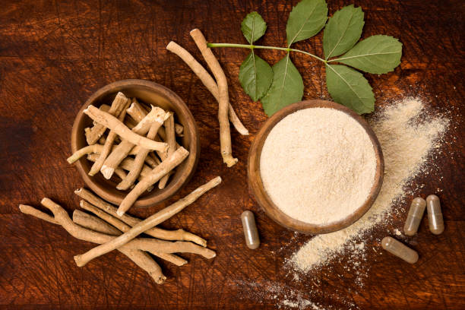

*Fig 4: ayurvedic medicine preparation from Withania somnifera*

* Bacopa monnieri
* Svarnamakshika bhasma
* Vaatakulantaka  rasa
* Sarpagandha vati
* Svarna bhasma
* Yogendra rasa

Most of the medication given in Ayurveda is customized and prepared based on the individual’s physical examination

#### **Panchakarma for epilepsy**

#### Panchakarma, an ayurvedic detox procedure, seeks to clear blocked channels in the body and mind brought on by unbalanced doshas. An ideal panchakarma includes nasal medication (nasya), reek bath (swedana), remedial purgation (virechana), remedial enemas (vasti), remedial oil massage (abhyanga), and treatment for the nervous system ( shirodhara). Our skilled ayurveda practitioners can create a detox regimen that is specifically tailored to your epilepsy problems and symptoms.

#### **Herbs for epilepsy**

It's also crucial to practise herbal tradition under the guidance of a qualified Ayurvedic doctor. Following are a few extras things a doctor might add to your treatment governance:

* Shankhapushpi-Convolvulus pluricaulis chosis.
* Vacha-Acorus calamus Linn.
* Tagara-Valeriana jatamansi Jones.
* Brahmi– Bacopa monnieri (Linn.) Pennell
* Lashuna-Garlic-Allium sativa Linn.
* Amalaki-Gooseberry-Emblica officinalis
* Rasna– Pluchea lanceolata C. B. Clarke.
* Yastimadhu-Glycyrrhiza glabra Linn.
* Jatamamsi-Nardostachys jatamansi Dc.

**Dietary and lifestyle management of epilepsy**

**NO**

* Reduce intake of alcohol, fish products, racy foods, and non-fresh, stale food in addition to fatty, sugary, adipose, and heavy foods.
* Cut off your intake of energising foods and drinks like alcohol, coffee, and spicy seasonings (e.g. chili, mustard, pepper, etc).
* Steer clear of pressure from within and from your emotions.
* Avoid poor sleeping patterns ( working, studying, or using computers and phones late into the night, going to bed late, sleeping late in the day).

**YES**

* Engage in ayurvedic practises like neti, nasya (oil painting oil droplets into the nostrils), toning, and massage ( yogic sinus sanctification).
* Practice relaxation and mindfulness techniques like yoga, meditation, and pranayama since they promote healing and have positive impacts on brain chemistry.
* Eat more foods that are high in vitamins and omega-3 adipose acids.
* Research has shown that a ketogenic diet is helpful in reducing the quantity and frequency of seizures. A diet that is heavy in fat, moderate in protein, and low in carbohydrates best describes it. Due to the diet, lipids are burned by the body instead of carbs. The body normally converts the carbohydrates in food into glucose, which is then transported throughout the body and is especially important for maintaining brain function. Even yet, if the diet contains little or no carbs, the liver converts fat into adipose acids and ketone bodies. Ketone bodies replace glucose as the brain's energy source once they enter the brain. Lowering the frequency of ketosis, a state characterised by a rise in ketone bodies in the blood.

## **Homeopathic medication**

Homeopathy is an alternate system of drugs which also serves as a remedy for epileptic diseases. Homeopathy is grounded on the conception that the causative agent of one response could act as a cure for another. minimum lozenge of the drug is always specified in homeopathy since the drug is grounded on the fact that the minimum lozenge of drug leads to a gradational yet effective cure of the illness or complaint. The treatment specified for epilepsy in homeopathy is primarily grounded on causative factors and characteristics of the seizure. The homeopathic drug is also substantially grounded on natural sauces while some medications include certain chemical factors..

The common herbs used in homeopathic epileptic medication include:

* Cicuta
* Artemis vulgarius
* Datura stramonium

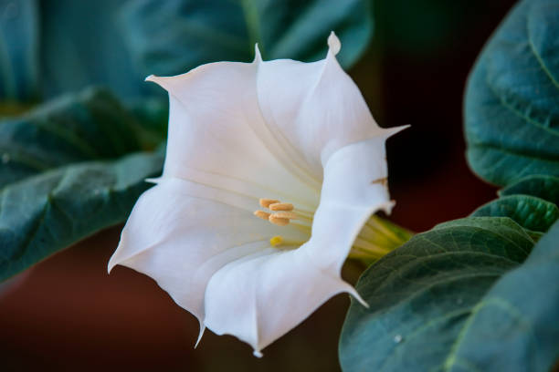

*Fig 5: Flowers from the plant Datura stramonium*

* Nux vomica
* Belladonna
* Chamomilla
* Plumbum
* Aethusa
* Hyoscamus

Homeopathy is also a highly preferred alternate medicine due to the absence of side effects.

## **Final Note**

With every nation and state conforming the advances in epileptic opinion and treatments, the treatment of epilepsy has come available to a lesser scale of population each around the world. Being a part of this developing nation, Sikkim is also developing as a center for treating the problem of epilepsy. Along with excellent aiding technologies, the state has also got some of the world’s stylish neurologists and neurosurgeons which also rises the standard of treatment.

**REFERENCES**

[www.sikkimtourism.gov.in](http://www.sikkimtourism.gov.in)

[www.ncbi.nlm.nih.gov](http://www.ncbi.nlm.nih.gov)

economictimes.indiatimes.com

sikkim.gov.in

[www.credihealth.com](http://www.credihealth.com)

https://curofy.com/doctors/gangtok,-sikkim,-india/neurology